* Purpose : Classwork.
* Date : 29/12/2025
* Author : Vikas Srivastava
* ID : 55984
* Batch ID : 25SUB4505
- Code : Write a program to implement a custom MyArray class in C++ that demonstrates abstraction, constructors (default, parameterized, copy constructor), and member functions to initialize and display array elements, showcasing object-oriented programming principles.
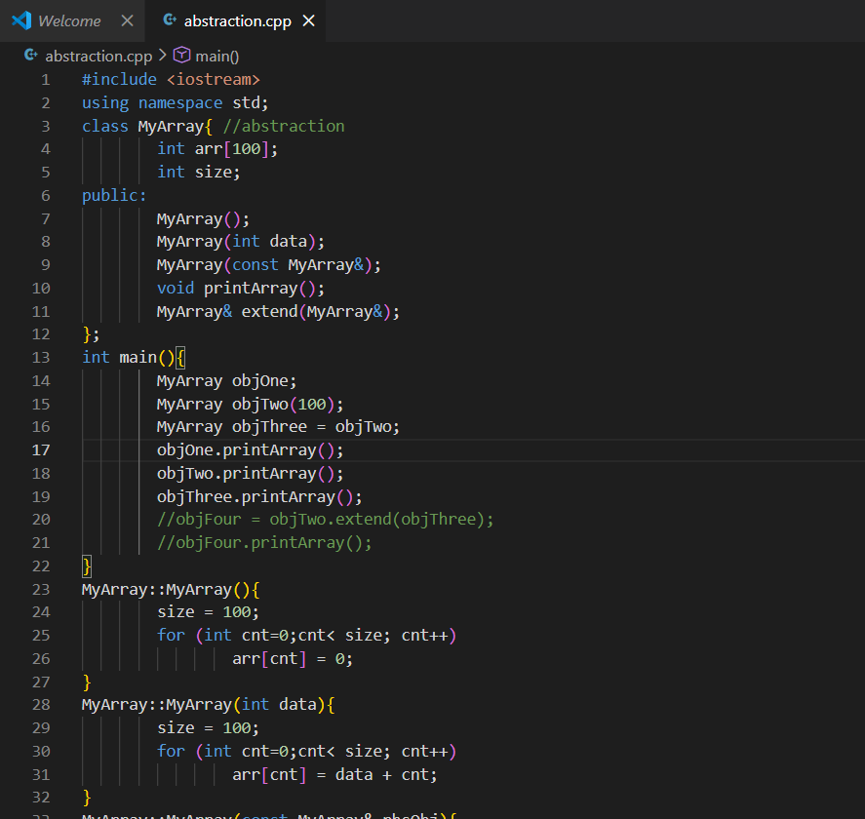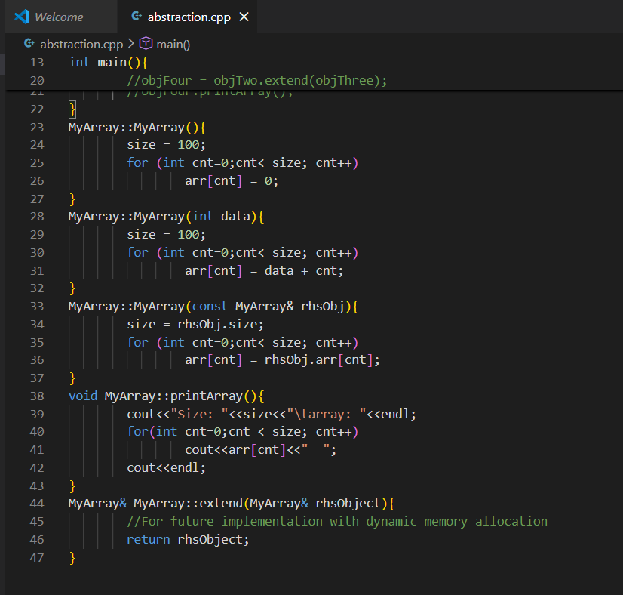
Output :
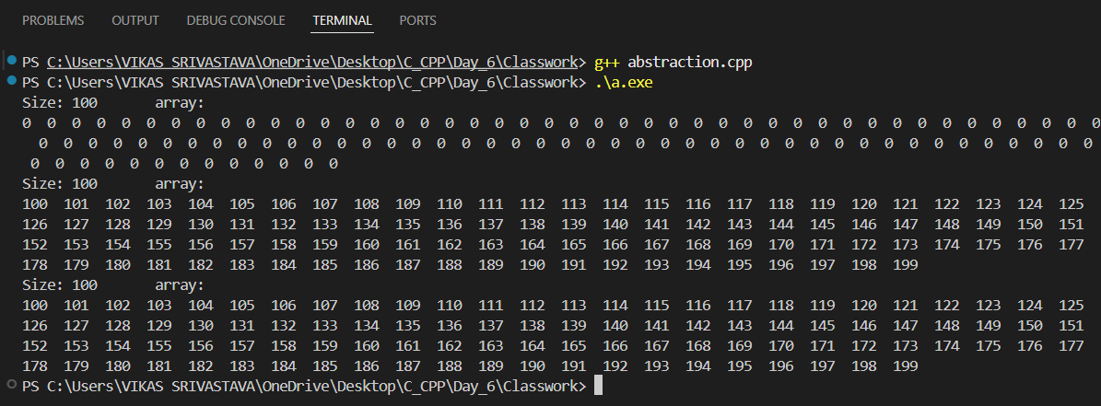

- Code : Write a program to demonstrate the invocation order of constructors and destructors in C++, including the default constructor, parameterized constructor, and copy constructor, and observe how the destructor is called automatically when objects go out of scope.
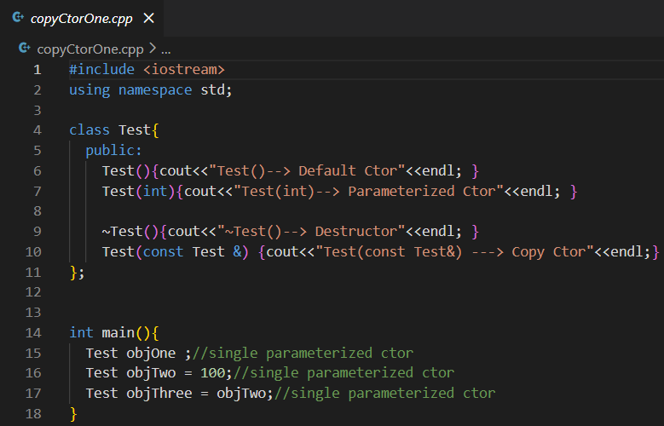
Output :
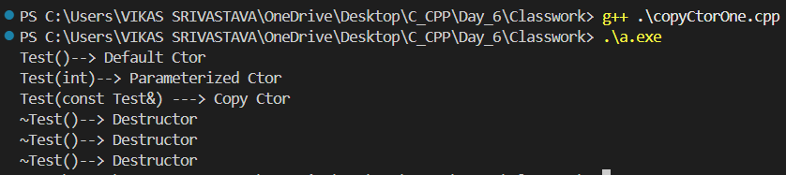

- Code : Write a program to demonstrate passing an object by reference to a function in C++, showing that no copy constructor is called when objects are passed by reference, and only the existing object is accessed and returned.
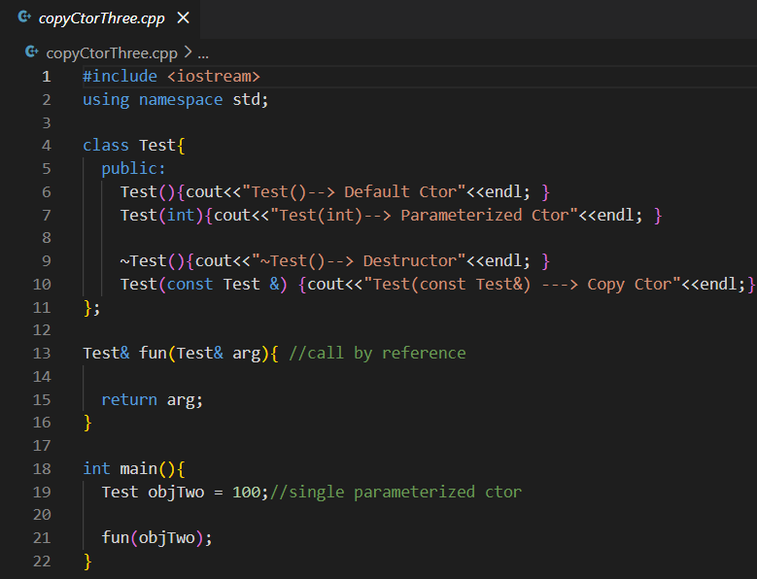
Output :
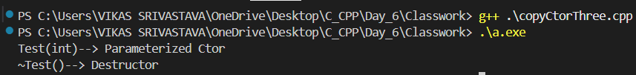

- Code : Write a program to demonstrate passing an object by value to a function in C++, where a copy of the object is created, resulting in the copy constructor being invoked, and the copied object is destroyed when it goes out of scope.
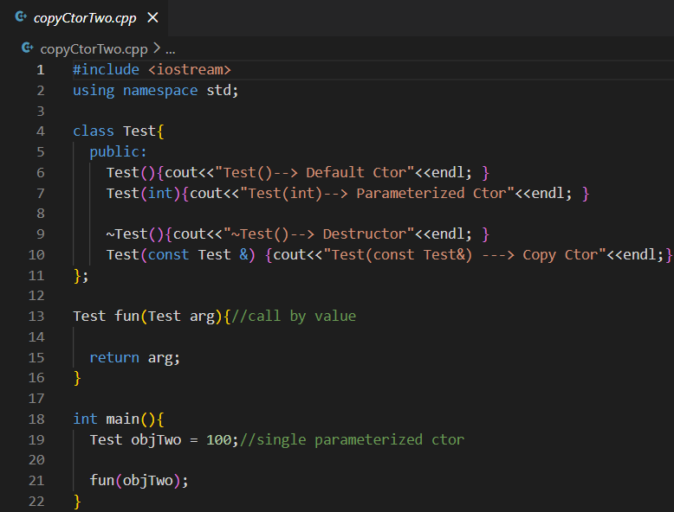
Output :
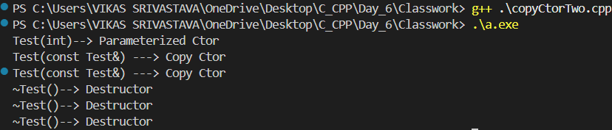

- Code : Write a program to demonstrate deep copy in C++ using a copy constructor, where dynamically allocated memory is duplicated for each object so that both objects manage separate memory, preventing issues like double deletion and dangling pointers.
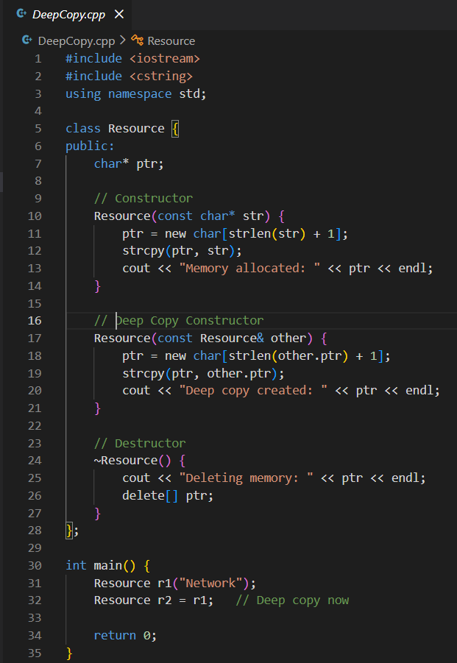

Output :
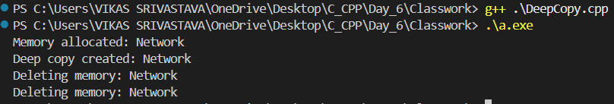

- Code : Write a program to demonstrate the concept of a friend class in C++, where one class (UsingTest) is declared as a friend of another class (Test), allowing it to access the private data members and member functions of the class, illustrating controlled access and encapsulation.
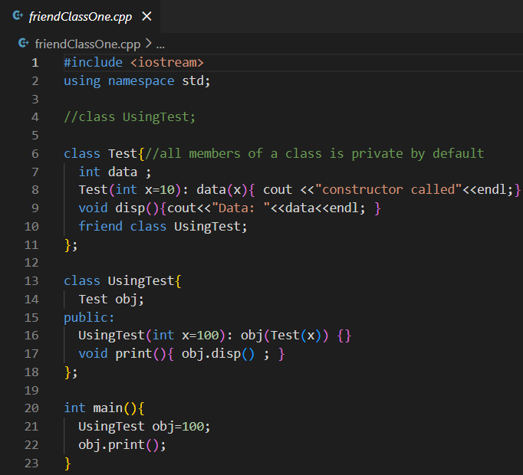
Output :
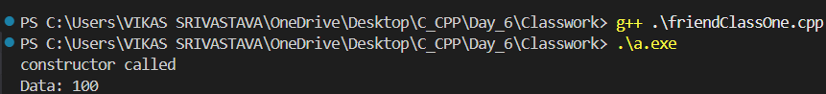

- Code : Write a program to demonstrate the use of a friend function in C++, where the main() function is declared as a friend of a class, allowing it to access the class’s private constructor and private member function, illustrating controlled access beyond normal encapsulation rules.
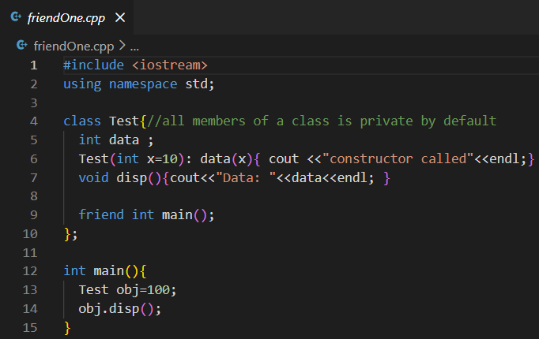

Output :
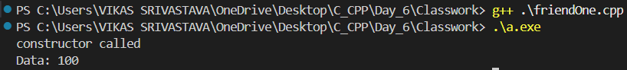

- Code : Write a program to demonstrate the use of a friend function in C++, where a non-member function is granted access to the private data members of a class to display internal object information.
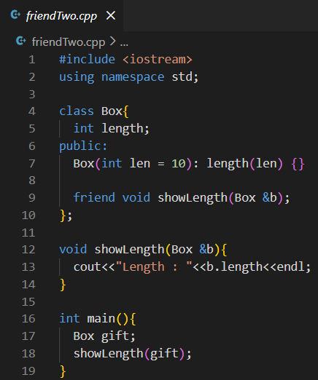
Output :

- Code : Write a program to demonstrate single inheritance in C++, where a derived class inherits public member functions from a base class and accesses them through a derived class object.
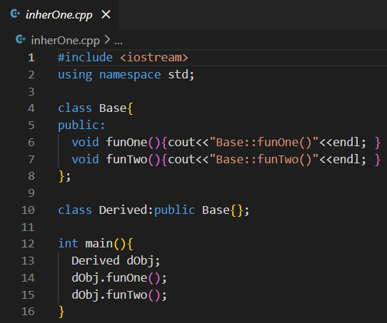
Output :
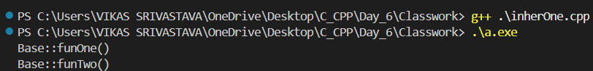

- Code : Write a program to implement a custom array class (MyArray) in C++ that demonstrates abstraction, default constructor, parameterized constructor, and copy constructor, along with a member function to display array elements, illustrating object creation and copying behavior.

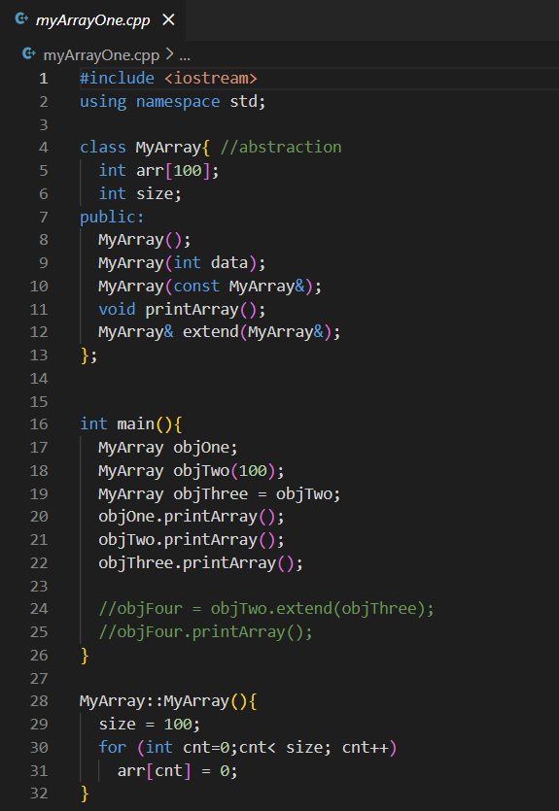
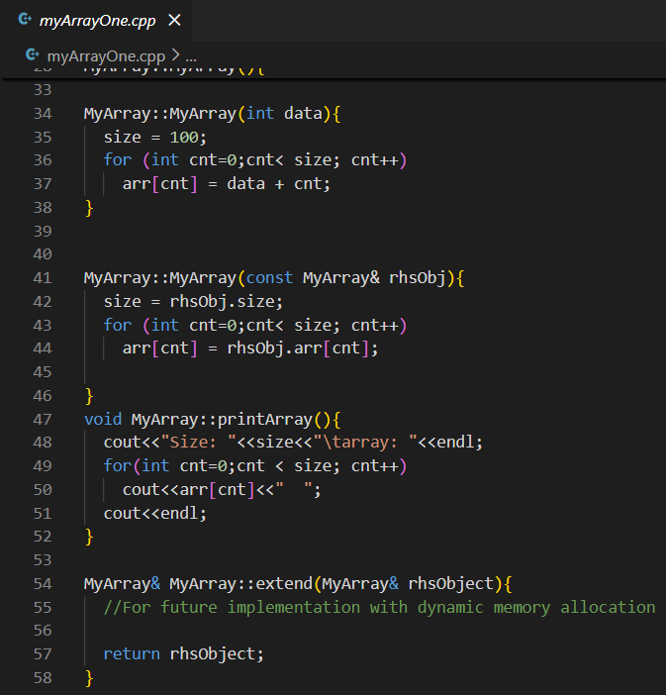
Output :
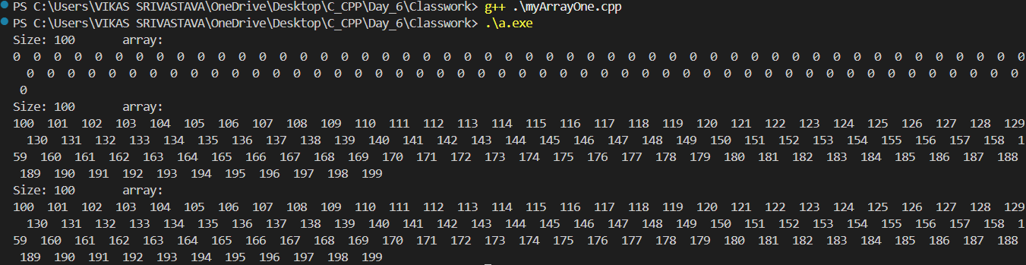

- Code : Write a program to demonstrate deep copy in C++ for a class that uses dynamic memory allocation, where a copy constructor allocates separate memory for each object to prevent dangling pointers and double deletion when objects go out of scope.
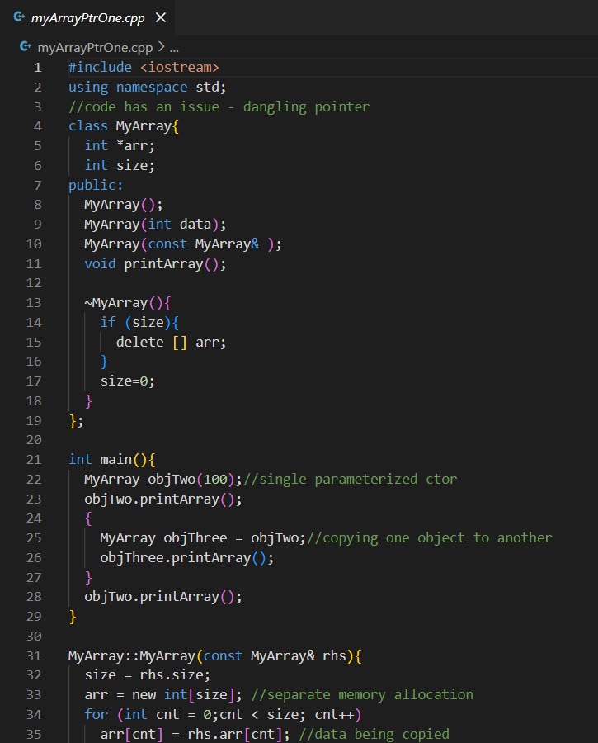
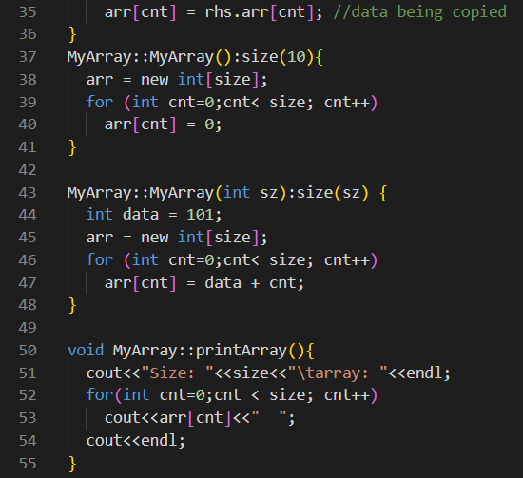
Output :
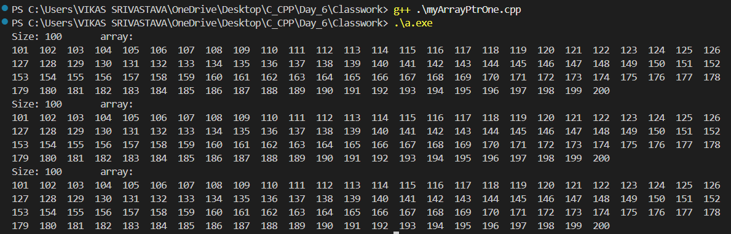

- Code : Write a program to demonstrate the use of the default copy constructor in C++, where an object containing a statically allocated array is copied to another object, resulting in a member-wise (shallow) copy that works safely because no dynamic memory allocation is involved.
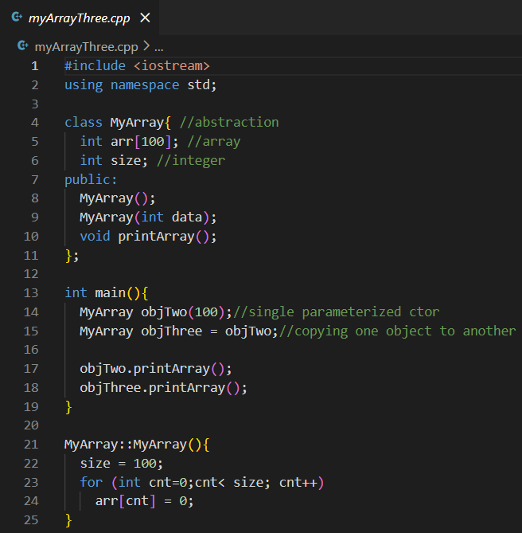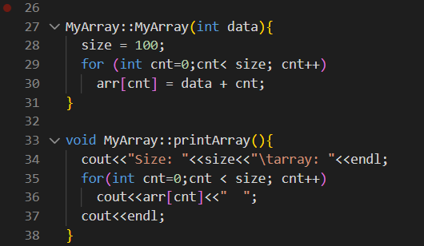
Output :
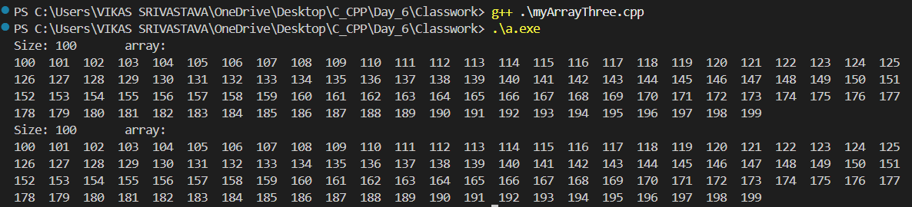

- Code : Write a program to implement a custom MyArray class in C++ that demonstrates static array usage, default, parameterized, and copy constructors, and a member function to extend (merge) two array objects into a new object, illustrating object copying, array manipulation, and return-by-value behavior.
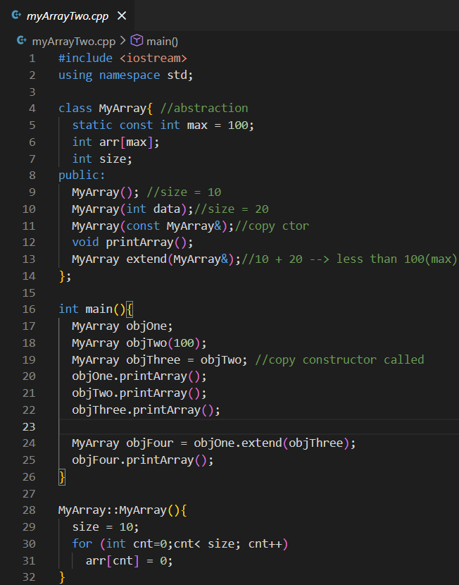
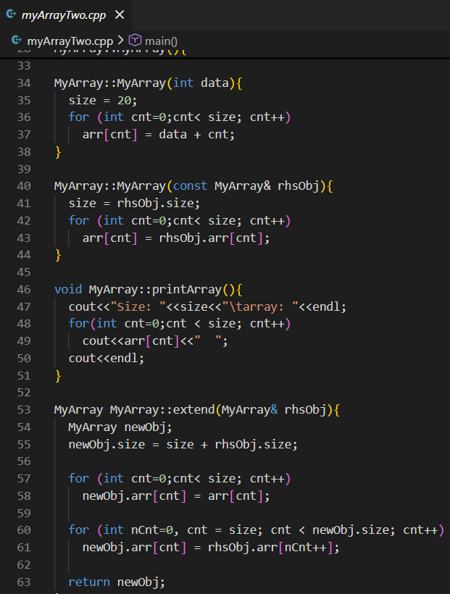
Output :
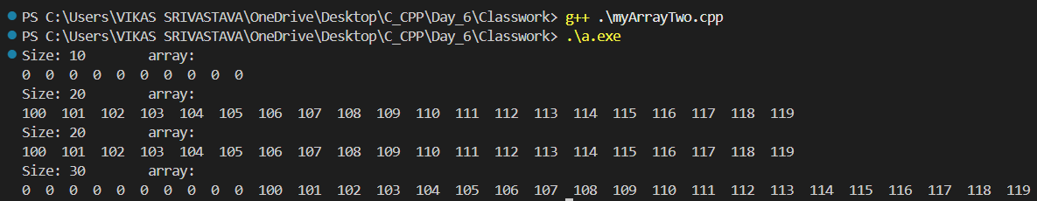

- Code : Write a program to implement the Singleton Design Pattern in C++, where a class ensures that only one object is created throughout the program by using a private constructor, a static pointer, and a static member function to provide controlled access to the single instance.
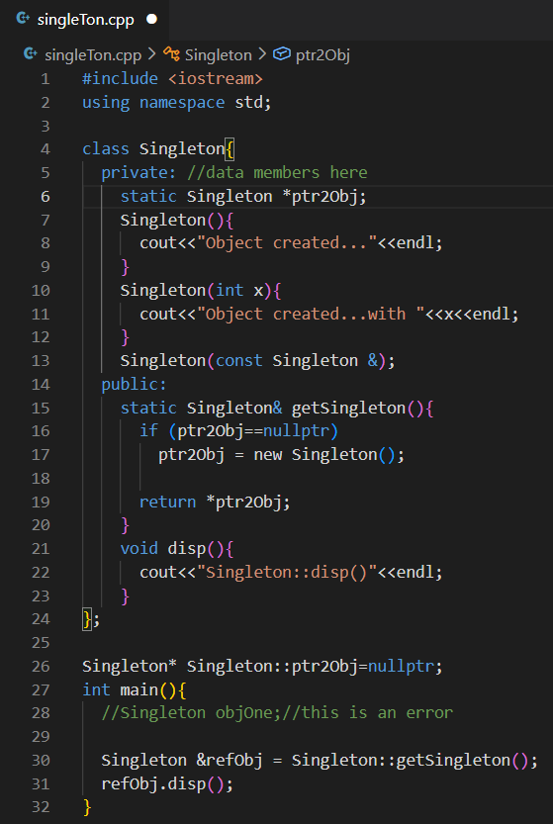
Output :
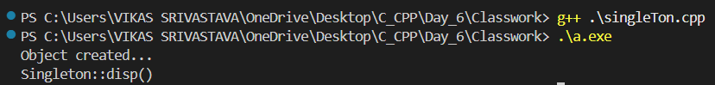

- Code : Write a program to demonstrate static data members and static member functions in C++, where a class-level variable is shared among all objects and can be accessed using both the class name and object instances.
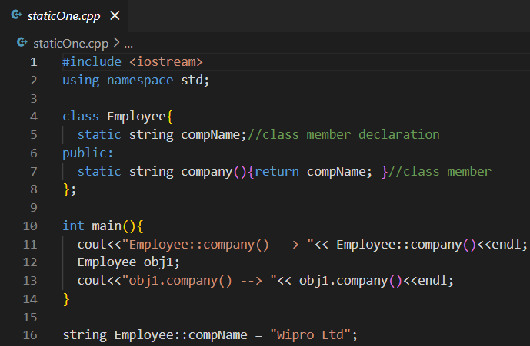
Output :
